

W

elcome to the third issue of “TM Connect.” The Air Force Branding & Trademark Licensing team continues to seek new and innovative ways to ensure the enduring popularity and protection of our Brand so you, our licensee, can experience even greater sales success. Not only has our continued networking with Fortune 500 companies led to the adoption of several brand licensing best practices, we have also participated in licensing courses to discuss the latest trends and developed new art assets for your use. Furthermore, we have expanded our anti-counterfeiting efforts by requiring the use of our security holograms, developing the [Online Merchant Seal](https://jpattonondemand.com/portal/Common/Resources.aspx), and by enhancing our online enforcement efforts. Additionally, we have partnered with the US Treasury Department to provide a way to [make royalty payments online](https://pay.gov/public/accesscode/).

As we look to the upcoming year, we will continue to nurture our 2016 advancements and be diligent in our efforts to provide you the best Brand possible so you can have the best sales possible.

# **Report online, pay online**

In June we introduced CRS, the Treasury Department’s [electronic bill pay system](https://pay.gov/public/accesscode/), to our licensees via “TM Connect.” We then invited select licensees to be part of the pilot group for the 2Q/16 reporting period.

We have taken their feedback and improved our processes for the 3Q/16 reporting period. Notably, we expanded the payment methods. Licensees paying online will now have the ability to pay using credit or debit card, checking or savings account, ACH Debit or Credit, PayPal, Dwolla, or FedWire.

Our office continues to incrementally grow the number of licensees enrolled in the CRS (Centralized Receivables Service) system. We have sent email invites to licensees included in the expanded list of users for 3Q/16. This list generally includes licensed companies whose names begin with C-P. Please check your emails, to include the general use/departmental email accounts, for an email with the following subject line, “NOTICE: New payment process for U.S. Air Force royalty payments.”

Those who paid online for 2Q/16 will continue to pay online. Those who did not receive the online payment invite for 2Q/16 or 3Q/16 will be invited for 4Q/16. All licensees will continue to report their quarterly sales through [Trademarx Online](http://licensing.trademarxonline.com/).

If your accounting department is prohibited from making electronic payments, please notify our office at [licensing@us.af.mil](mailto:licensing@us.af.mil).

Direct all questions on how to make a payment through CRS to their helpdesk - 1-855-649-1181 - between the hours of 7 a.m. and 7 p.m., Central Time, Monday through Friday, excluding holidays.

# **Online search reveals disapproved, unapproved merchandise**

A recent in-house review of several licensees’ web sites revealed numerous disapproved or unapproved designs being advertised online, as well as multiple designs that had been marked as “approved with changes” in the approvals system, yet the online depiction of the product was not the corrected version.

To help ensure your license remains in good standing with the USAF, we encourage you to reconcile your merchandise offerings with your proof of approvals from our office and ensure only accurate images of approved merchandise are displaying on your websites and in your marketing materials.

Any product that does not have a corresponding proof of approval should be submitted immediately into the [Trademarx Online](http://licensing.trademarxonline.com/) Design Approvals system.

Our office has 20 business days to review and comment on any submission. Per the license agreement, any submission not approved within those 20 business days is considered disapproved.

# **Trouble resetting your Trademarx Online password?**

If you have recently attempted to reset your password in Trademarx Online but did not receive an email with reset instructions, you may have entered a user name that is no longer active in the system. Please ensure you are using the most recent email address. This may be the departmental email address for your company.

Once you reset your password, share the password with the other Trademarx Online users in your company – generally the accounting department, sales department, and art department.

# **Adding general use/departmental emails to profiles**

Our office is still updating licensee profiles with general use/departmental email address. In the Spring and Summer issues of “TM Connect” we advised of the need for these monitored email accounts. The departmental email address will be used to access Trademarx Online’s systems, to receive e-bills from the Treasury Department’s CRS system, and to ensure continuous receipt of communication regardless of personnel changes.

If you have not yet provided a departmental email address, please do so immediately. We will begin deactivating personal email accounts in Trademarx Online in early 2017.

# **USAF adds new companies to their licensing portfolio**

The USAF Branding & Trademark Licensing team would like to welcome the following companies into our licensing portfolio: Adamation LLC, Allied Products Corporation, Chrome Domz, Heart Gifts by Teresa, Topper Manufacturing, and Winning Streak Sports.

47.9% of the licensed, Air Force-branded merchandise sold in 2Q/16 was in the “apparel” category.

We want to also recognize the following renewed licenses: Fox-2 Flightgear LLC, The Manual Woodworkers & Weavers Inc., and Mi Engraving.

You can see the complete listing of current licensees [here](http://www.trademark.af.mil/Licensing/CurrentLicensees.aspx).

# **Air Force Trademark Licensing website gets new look**

Our website – [www.trademark.af.mil](http://www.trademark.af.mil) – has a new look. Earlier this summer we updated our site to provide more relevant information in a more aesthetically appealing way.

You’ll notice our home page has been redesigned from its former text-heavy layout to a cleaner, simpler graphic design intended to get you where you need to go with a few quick clicks. We have also created a document library so you can easily let us know when you are requesting changes to your license agreement, such as adding or removing a manufacturer or modifying distribution channels.

To help reduce the occurrences of unlicensed use of our marks that cut into your sales, we have removed the high resolution images of our Symbol from the website. High resolution images remain available through [JPatton On Demand](https://jpattonondemand.com/portal/LOD/logos.aspx?EG=Logos).

We’ve also removed the license applications from the website. To receive a renewal application you will need to complete a [License Renewal Application Request](http://www.trademark.af.mil/Licensing/Applications/RenewALicense.aspx). We highly recommend submitting this request at least six months prior to your license expiring. Companies may not continue sales under an expired license. Submitting a renewal application does not extend your license agreement, nor does submitting a renewal application guarantee your continued relationship with the Air Force Brand.

We’re not done with the site yet. We are working to create an online form for your annual business plan as well as placing filters on our [Current Licensees](http://www.trademark.af.mil/Licensing/CurrentLicensees.aspx) page so potential customers can better find vendors offering the products they are looking for. Please bear with us as we continue to update the site with important licensing tools.

# **Final Thoughts**

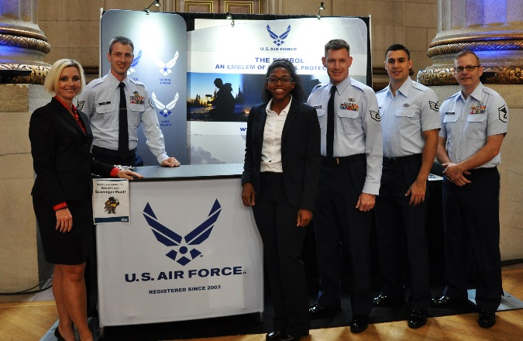This quarter was especially eventful for the USAF Branding & Trademark Licensing team. We had the honor of adding a talented intern to our staff – Ms. Maya Johnson. We engaged in an educational and interactive licensor workshop organized by SPLiCE. We attended the [USPTO National Trademark Expo](https://www.uspto.gov/trademark/trademark-updates-and-announcements/about-usptos-national-trademark-expo). We received our first online royalty payments through CRS. And, through your dedicated marketing and retail teams, we collected $1M in royalties in a fiscal year for the first time in the program’s history. These royalties directly support Air Force Airmen and their families by helping fund morale, welfare and recreational events. We appreciate your continued support of our great Air Force and our Airmen.

# **Important Links**

[Trademarx Online](http://licensing.trademarxonline.com)

[JPatton On Demand](http://jpattonondemand.com/)

[USAF Branding & Trademark Licensing](http://www.trademark.af.mil)